**Tic Tac Toe**

**Overview**

This is a Python-based Tic Tac Toe game.  
Two players take turns marking spaces on a 3x3 board with their symbols (**X** and **O**). The goal is to get three in a row—horizontally, vertically, or diagonally—before the other player.

The game runs until a player wins or all spots are filled, ending in a tie.

**How It Works**

Setting Up Players

The game begins by asking for the names of two players.

* Player 1 uses **X**.
* Player 2 uses **O**.  
  Player 1 always goes first.

**Displaying the Board**

The board is shown as a grid of 9 spots, numbered 1–9:

1 | 2 | 3

---|---|---

4 | 5 | 6

---|---|---

7 | 8 | 9

As players take turns, their chosen spots are replaced with **X** or **O**, and the board updates after each move.

**Player Input**

On each turn, the current player selects a number (1–9) to place their symbol.

* If the number is outside the range, the player is asked again.
* If the spot is already taken, the player must choose a different one.

**Checking the Result**

After every move, the game checks for winning conditions:

* Three in a row across any row
* Three in a row down any column
* Three in a row diagonally

If a player achieves one of these, they win immediately.

**Tie Condition**If all 9 spots are filled without a winner, the game ends

**Example Run:**

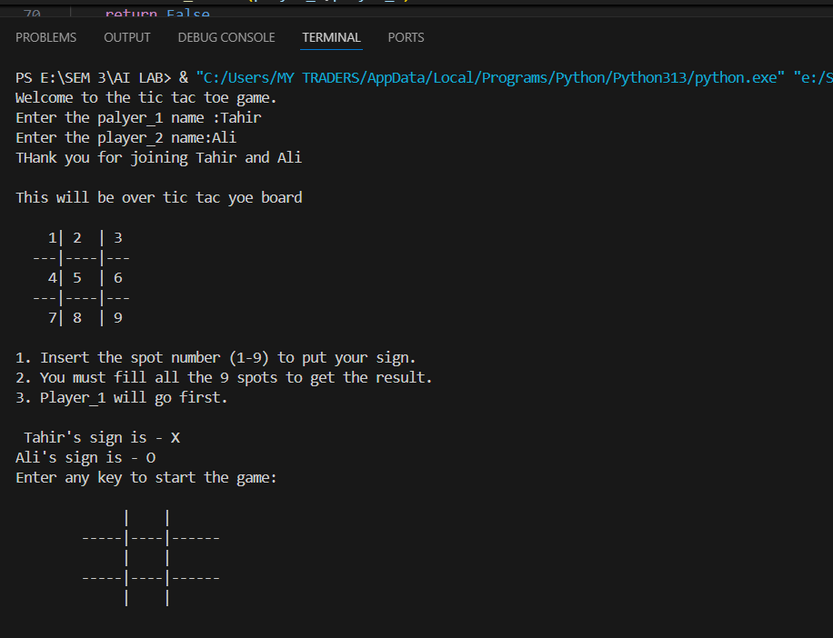

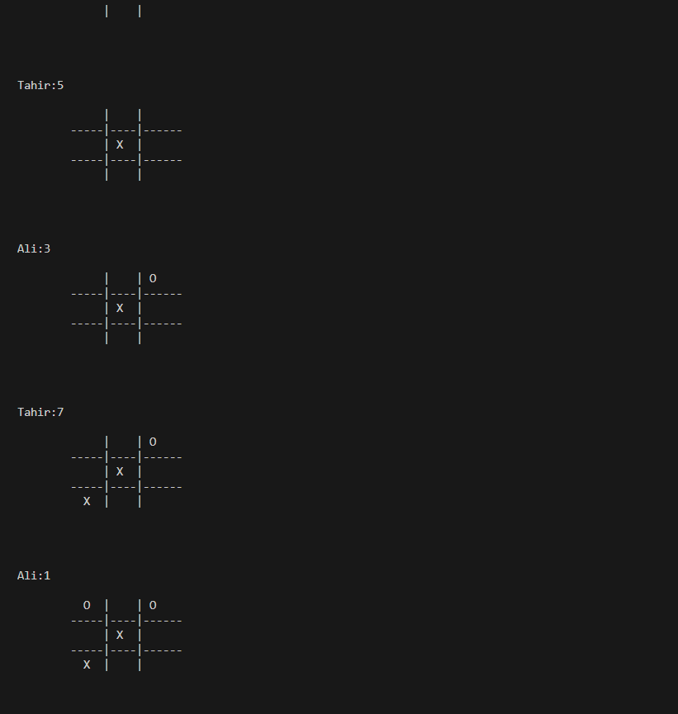

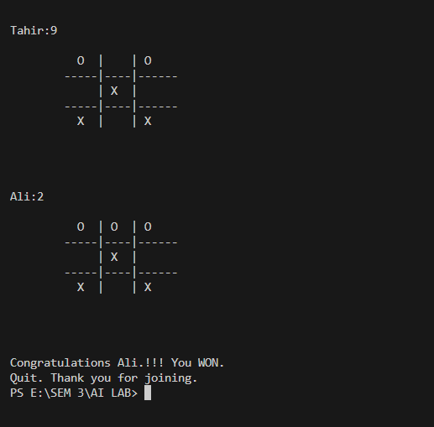

**Features**

* Two-player interactive gameplay
* Validates player input
* Prevents overwriting taken spots
* Displays the board dynamically after each move
* Detects win or tie automatically